**A Comprehensive analysis of financial performance**

1. **Introduction**

**1.1 Overview**

The banking sector is one of the most significant financial sectors of an economy and they play an indispensable role to strengthen the whole economy and its growth. Economic growth is one of the final goals of any economic system and the development of the financial sector accelerates economic growth.

**1.2 purpose**

It helps to formulate capital and accelerate the investment, create the medium of exchange help in export and import, control the credit, promote industrial development and also implement the monetary policy of the government. Therefore, the stability and the solvency of the bank have to be checked so that it can earn enough profit choose survive in the long run.

1. **Problem definition and design thinking** 
   1. **Empathy map**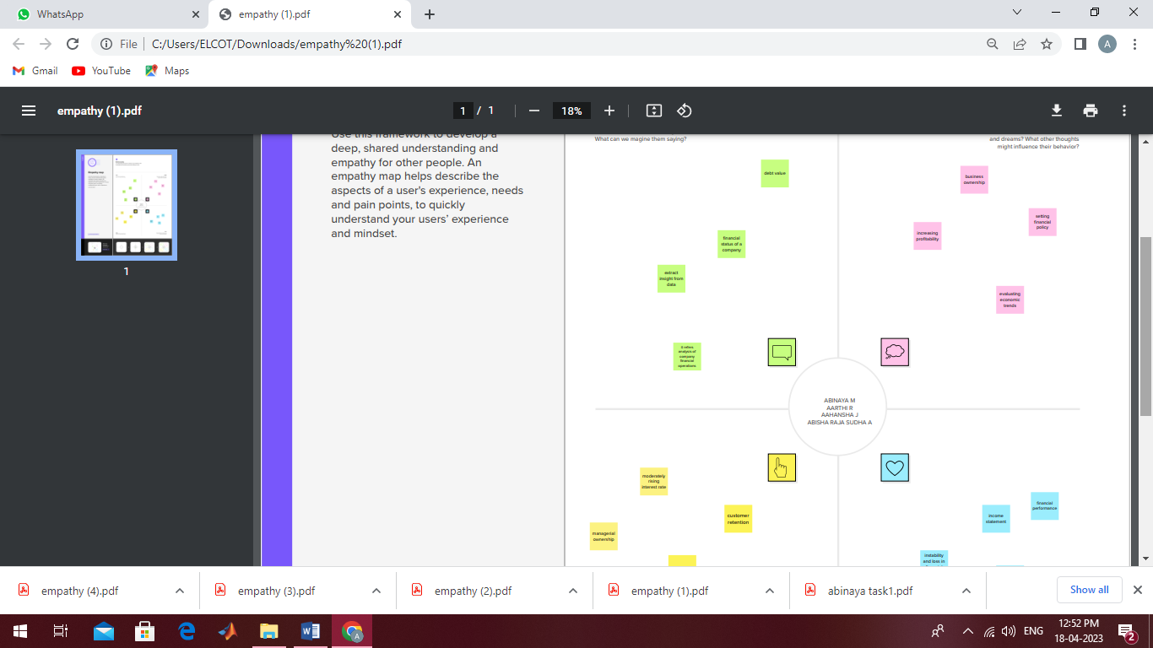
   2. **Ideation & brainstorming map**

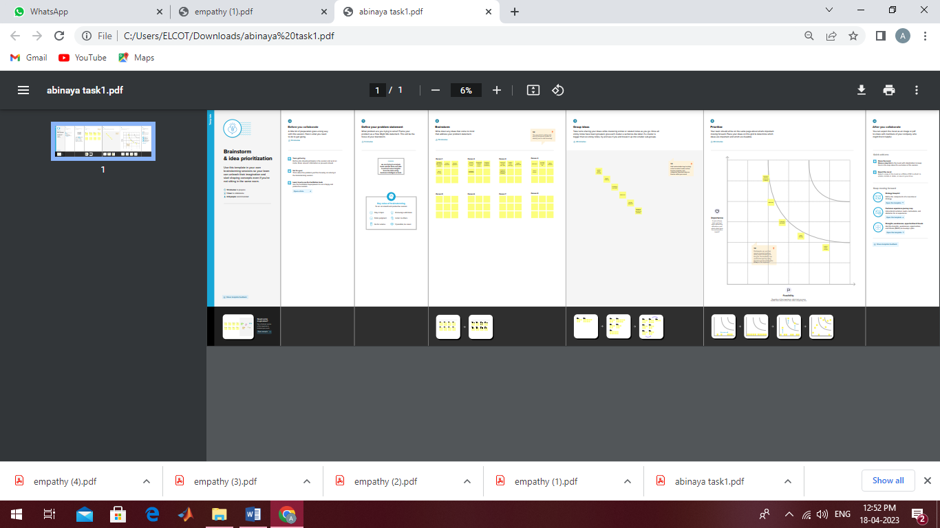

**3. RESULT**

The financial performance identifies how well a company generates revenues and manages its assets liabilities and the financial interests of its stakeholders and stockholders.

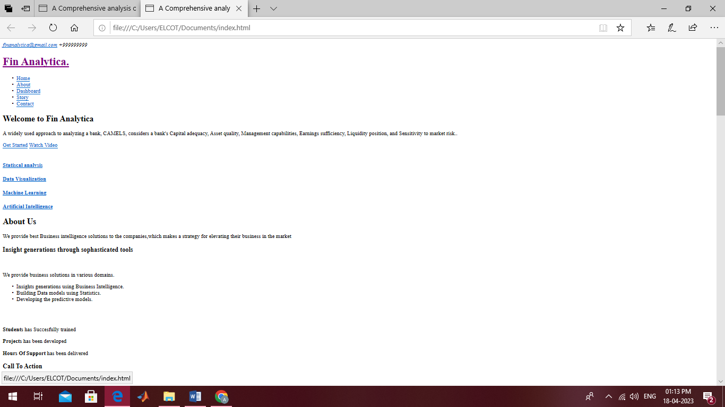

**Story**

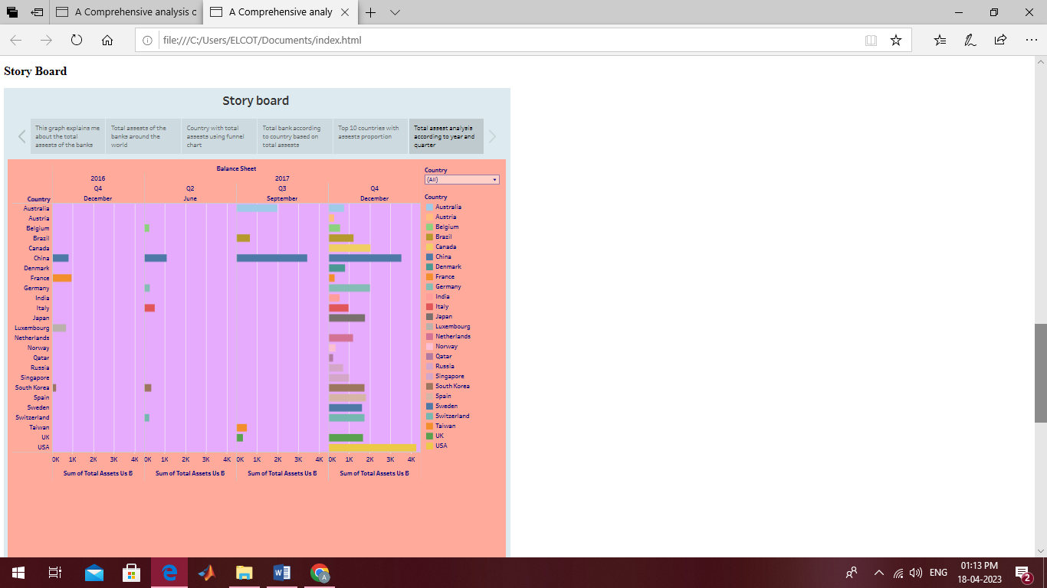

**Dashboard**

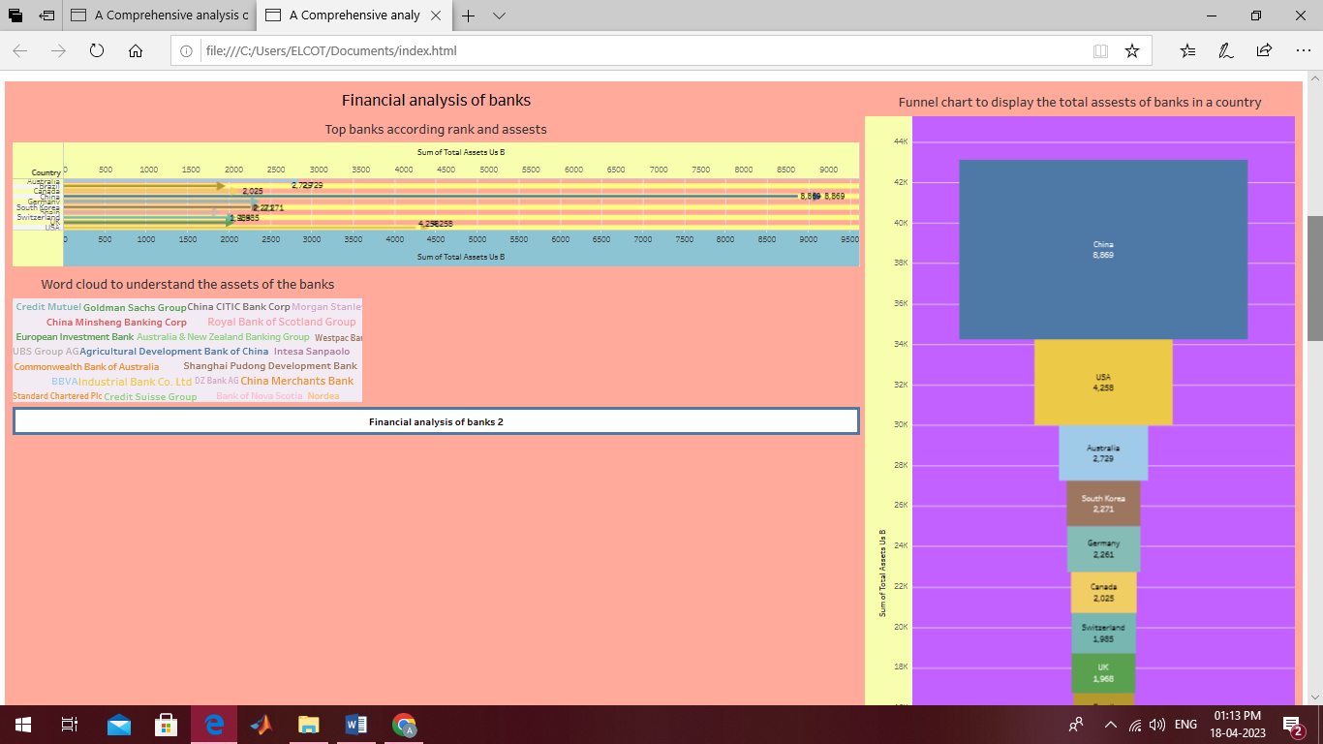

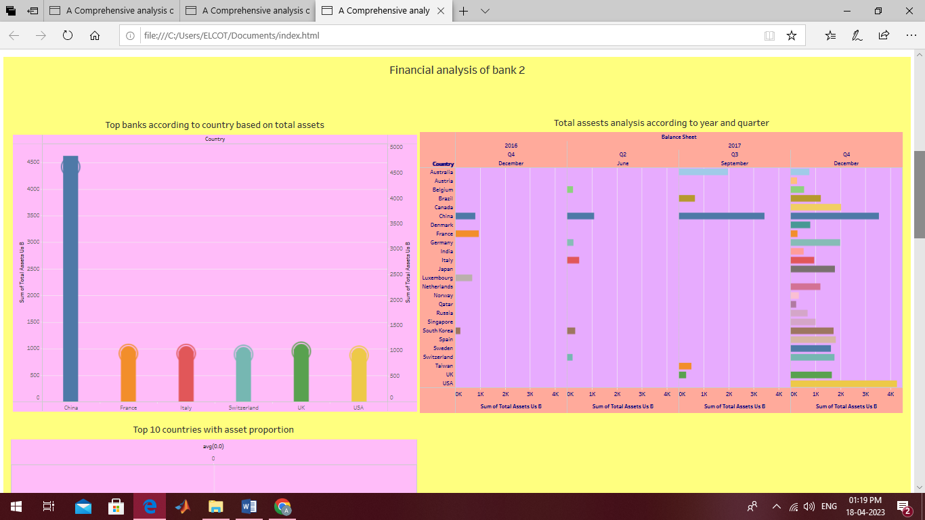

**4. ADVANTAGES & DISADVANTAGES**

Advantages:

* A significant benefit of financial statements is that it can reflect many financial risks and provide a warning for bank to avoid risks such as credit risk and interest rate risk.
* It helps in determining how efficiency a firm or an organisation is operating.

Disadvantages:

* The financial analysis does not consider cost price level changes.
* The analysis of financial statements cannot provide a basis for future estimation, forecasting budgeting and planning.

**5. APPLICATION**

Financial analysis is used to evaluate economic trends, set financial policy, build long term plans for business activity, and identify projects or companies for investment. This is done through synthesis of financial numbers and data.

**6. CONCLUSION**

This project analyses the function of financial statements for a bank to use it as operation guideline and explain how useful for a bank to invest and avoid risks. Different parts of financial statements contribute unique use value for bank. Specifically, to understand the solvency, financial workers in a bank can analyse cash flow statements to check the operation position and profit of a bank.

**7. FUTURE SCOPE**

Career prospects in banking and insurance graduate can get offers for job of an accountant, cashier, broker, auditor, equity research analyst, market analyst and sales manager in both private and government organizations.

**8. APPENDIX**

**A. Source code**

**https://drive.google.com/file/d/11C-9EiK9AB5MwjLNhQYmuPByc67Yn8ef/view?usp=share_link**